Identifying the wavelength of laser light

**Aim**

Identify the wavelength of a red, green and blue laser

**Equipment**

* Diffraction grating
* Red, blue and green laser
* Bosshead and clamp x2
* Retort stand
* Ruler

**Method**

1. Setup the laser aiming at the floor through a diffraction grating
2. Record d which is the distance between the slits of the diffraction grating (in units m)
3. Measure the distance from grating to floor
4. Measure the distance between the central fringe and the 1st, 2nd, 3rd and possibly 4th order as well as which order they are  
     
   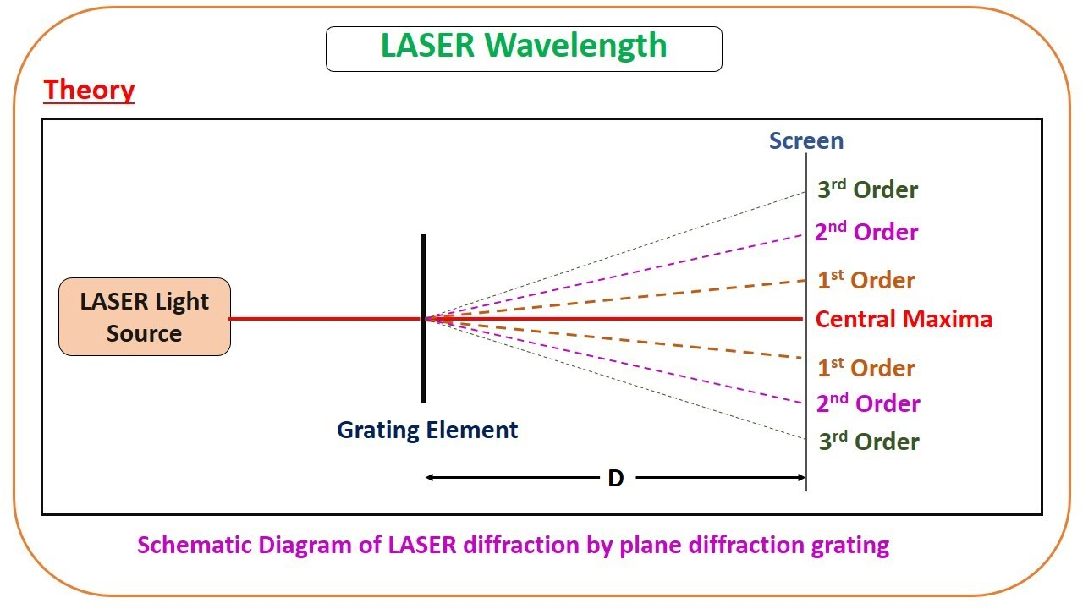
5. Repeat for each colour

**Pre lab**

1. For this experiment, identify the independent, controlled and dependent variables
2. Write an appropriate hypothesis

**Post lab**

1. Use the information to record the angle between the central maxima to the orders
2. The formula associated with the diffraction gratings is d sin Ɵ = n λ where d is the distance between slits, Ɵ is the angle between the order and central maxima, n is the order, and λ is the wavelength. Use the formulae to graph each colour in such a way that you can find the wavelength using the gradient of the graph
3. Using the gradient of the graph, calculate the wavelength of each coloured laser
4. Calculate the absolute error and percentage error
5. Compare the wavelength of each colour with each other. Is this to be expected?